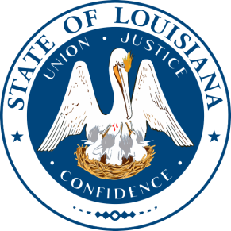

State Interagency Coordinating Council

Nominating Committee Meeting

December 7, 2018

2:30 p.m. – 3:30 p.m.

State Capitol Annex

Suite 136 Conference Room

1051 N. Third Street
Baton Rouge, LA 70802

